**Project Title**

WQU Capstone Project – Group 25 – Draft Project

Commodities – Oil / Oil products relationships in different markets

**Problem Description**

Context

Crude oil prices typically maintain certain statistical relationships with the products refined from individual crude oils. These relationships can be described using many standard multivariate techniques, among them correlation and Principal Components Analysis. In addition, times series techniques can be used to describe the behavior of the individual crude and product prices. A project in this area would assess price relationships for US crudes (e.g. WTI, Kern River) refined in the US against their refined products and then perform similar local comparison for Nigerian crudes (e.g. Bonny Light, Qua Ibo) and North Sea crudes (e.f. Brent Blend, Ekofisk)

Scope of Research Project

* Identify appropriate crude oil and product prices in at least three separate locations
* Collect price data for the crudes and products and check the data for missing observations and bad data
* Perform Exploratory Data Analysis on the data including time series plots, Q-Q analysis
* Compare key statistical metrics across the different markets and assess similarities and
* differences, including measures like variance, skew, kurtosis, covariance, ARIMA
* parameters
* Discuss possible economic explanations for differences

**Getting Started**

These instructions will get you a copy of the project up and running on your local machine for development and testing purposes. See Deployment / Installation for notes on how to deploy the project on a live system.

**Prerequisites**

This project was developed within the below environment:

1. **Operating system** – Microsoft Windows 10
2. **Python Version** – Python 3.7
3. **Python Modules**
   1. pandas
   2. matplotlib
   3. scipy
   4. stats
   5. statsmodel.api
   6. seaborn
   7. sklearn

**Deployment / Installation**

1. **Operating system** – Microsoft Windows 10

Visit <https://www.microsoft.com/software-download/windows10> for instructions on installing Windows 10 operating system.

1. **Python Version** – Python 3.7

It is advisable that the Python modules are installed using Anaconda package. Please visit <https://www.anaconda.com/distribution/> for further instructions on installation.

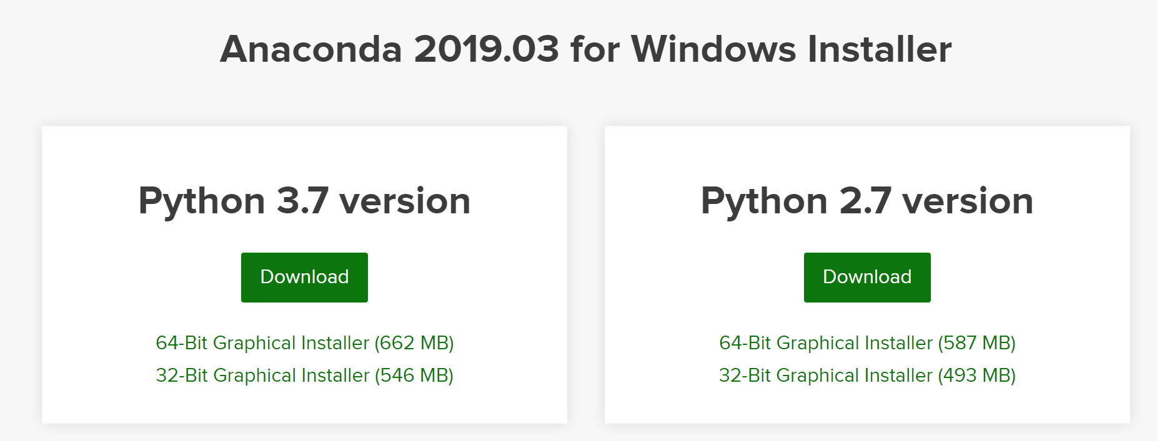

1. **Python Modules**

As noted, the anaconda package comes preloaded with numerous libraries including all the modules listed below. This can be inspected by checking the Anaconda Navigator Environment for packages installed in the environment – see screenshot below.

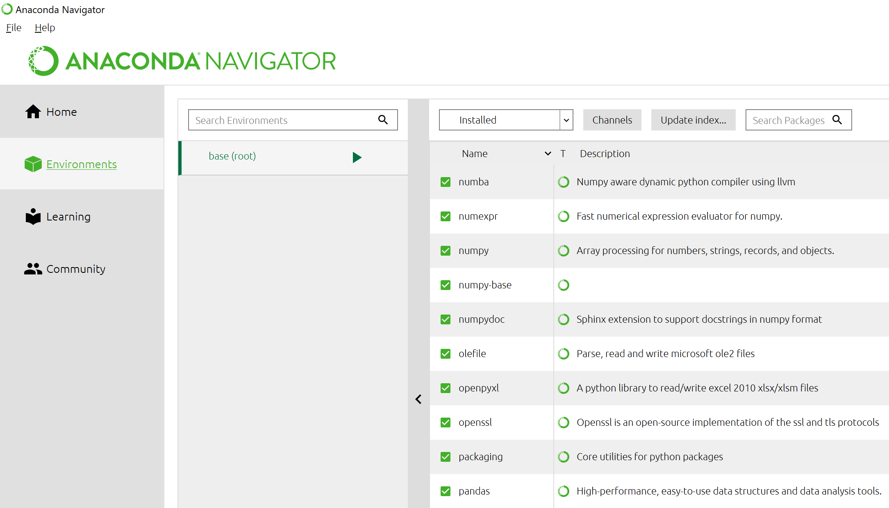

However, for further installation of the packages, use the following command in the Anaconda Prompt environment

*Conda install module*

**Running the tests**

The Python code for the Project can be found in the Github address below:

<https://github.com/tarunk/CAPSTON>

Load the code into the Python environment (Anaconda IDE) and run as necessary.